**Name / address of all the applicants:**

HARSHA VARDHAN CHINNAKKAGARI - 190070014

${Student}^{1}$, Department of Mechanical Engineering, Koneru Lakshmaiah Education Foundation (KLEF, Deemed to be university), Green Fields, Vaddeswaram, Guntur, A.P, India-522502.

B RAVI PRABHAT - 1900700140

${Student}^{2},$ Department of Mechanical Engineering, Koneru Lakshmaiah Education Foundation (KLEF, Deemed to be university), Green Fields, Vaddeswaram, Guntur, A.P, India-522502.S

S YASHWANTH SRI SAI REDDY - 190070141

${Student}^{3},$ Department of Mechanical Engineering, Koneru Lakshmaiah Education Foundation (KLEF, Deemed to be university), Green Fields, Vaddeswaram, Guntur, A.P, India-522502.

CHARAN VALLABHANENI – 190070103

${Student}^{4},$ Department of Mechanical Engineering, Koneru Lakshmaiah Education Foundation (KLEF, Deemed to be university), Green Fields, Vaddeswaram, Guntur, A.P, India-522502.

Dr DVA RAMASASTRY

${Professor}^{1} \& HOD,$ Department of Mechanical Engineering, Koneru Lakshmaiah Education Foundation (KLEF, Deemed to be university), Green Fields, Vaddeswaram, Guntur, A.P, India-522502.

K SHASHIKANTH

$Asst. {Professor}^{2},$ Department of Mechanical Engineering, Koneru Lakshmaiah Education Foundation (KLEF, Deemed to be university), Green Fields, Vaddeswaram, Guntur, A.P, India-522502.

B KIRAN KUMAR

$Asst. {Professor}^{3},$ Department of Mechanical Engineering, Koneru Lakshmaiah Education Foundation (KLEF, Deemed to be university), Green Fields, Vaddeswaram, Guntur, A.P, India-522502.

***Title of the article:***

**PORTABLE FLOOR CLEANER**

**Use of the article:**

The main object of this project is to reduce human effort and should be capable of cleaning different types of floors by performing multiple tasks which can increase the effectiveness and can be operated by anyone. For example in household cleaning, the people manually perform the entire cleaning process using their hands which results in risks of causing injury or lack of effectiveness of work, with this floor cleaner we can make that process in an easier way like walking along with the cleaner and move it where we want to clean by which a single hand can move and hold the handle in our conscience. Different types of floor cleaners are nowadays is commonly used in both household and industrial purposes. Spreading its use across multiple cleaning applications like vacuum, mopping and drying where our cleaner is proving its worth. In this project, the cleaner has been designed which basically less in weight , affordable and portable. The floor cleaner makes the work easier by accomplishing numerous tasks involved in floor cleaning at a time. This floor cleaning machine can also be used in different types of floors where the surface is uneven by setting a different type of brush which is suitable for that type of floor . This floor cleaner can be also used in industries where it requires some minor modifications according to the industry it serves. So with the help of this we can save time and effort.

**PORTABLE FLOOR CLEANER**

**Brief description of the device:** Our product is basically designed for cleaning floors which cleans effectively by performing different cleaning processes and also portable so anyone can handle it very easily and it should affordable compared to the similar products available in the market and it can even run on battery.

**Making the Power Supply and Motor**

### Setting up the motor and working process

Our product runes on both battery and direct power supply and we use universal motors which has a voltage of less than 1000 watts , the motor we use for application of mopping purpose and a container for storing water which is sprinkled on floor and a small container which contain liquid floor cleaner which mixes with water and sprinkle of floor by which the rotating brushes cleans the floor.

**FRONT VIEW**

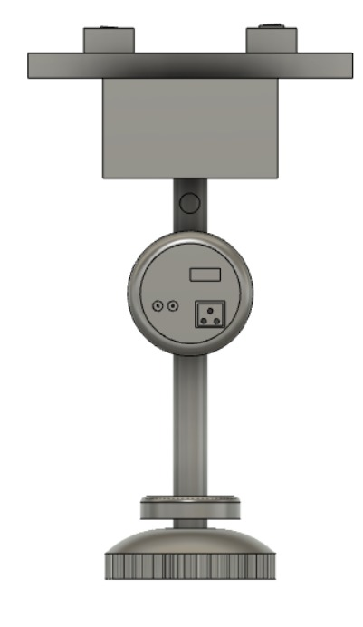

**LEFT VIEW**

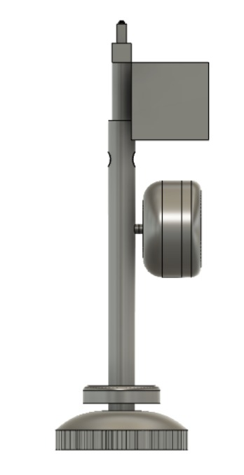

**TOP VIEW**

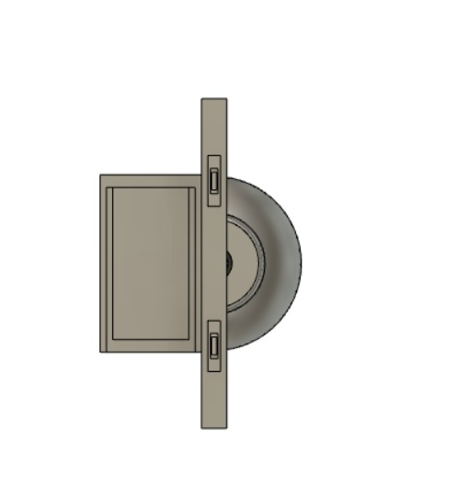

**BOTTOM VIEW**

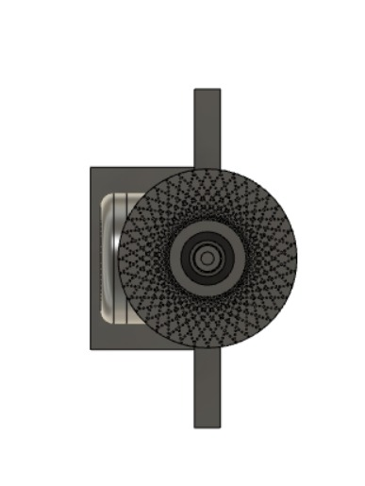

**RIGHT VIEW**

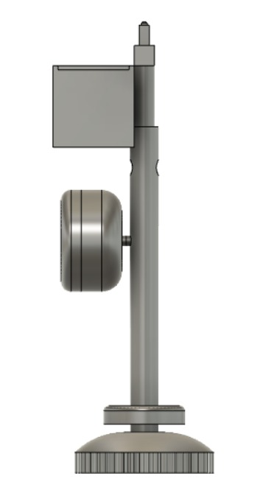

**REAR VIEW**

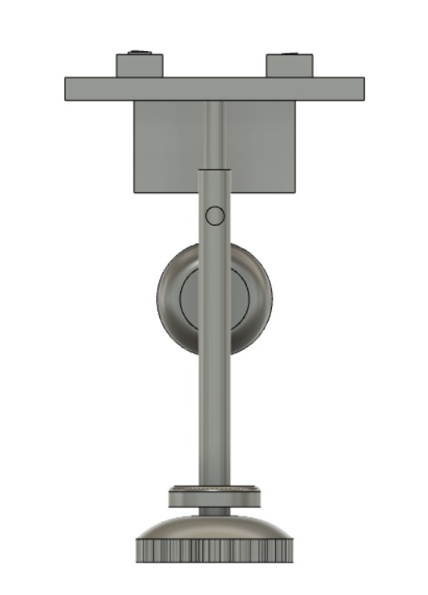

**ISOMETRIC VIEW**

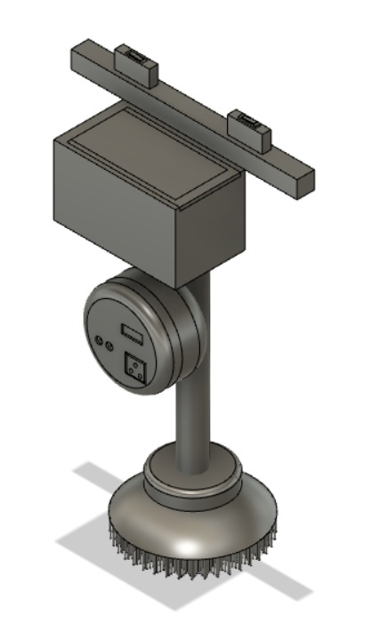

**Components as mentioned in the above discription:**

* Mopping Brushes
* Motors
* Battery
* Wires & Switches
* Battery Indicator